swd

|  |  |
| --- | --- |
| **Name** | **Team Number** |
| **Tomoki Koike** | **R06** |

AAE 251: Introduction to Aerospace Design

Assignment 9— Aircraft Performance II

**Due Tuesday April 9, 10:00 am on Blackboard**

**Instructions**

*Write or type your answers into the appropriate boxes.****Make sure you submit a single PDF on Blackboard.***

*Make sure you keep a record of submission receipts or the confirmation emails after each submission as a proof that your submission was accepted.*

|  |  |  |
| --- | --- | --- |
|  | **Score** | **Max** |
| **Question 1** |  | **16** |
| **Question 2** |  | **6** |
| **Question 3** |  | **14** |
| **Question 4** |  | **6** |
| **Question 5** |  | **7** |
| **Question 6** |  | **8** |
| **Question 7** |  | **8** |
| **TOTAL** |  | **65** |

**MATLAB FUNCTIONS**

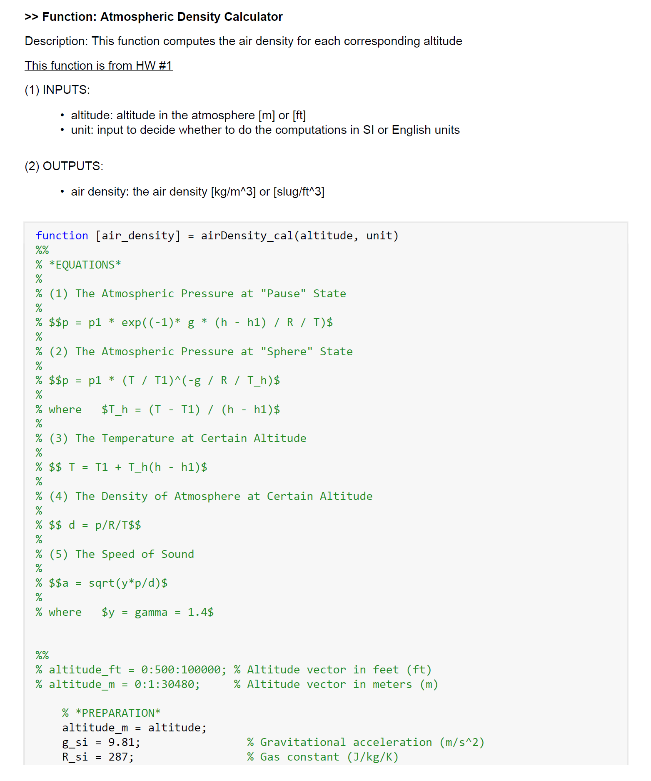

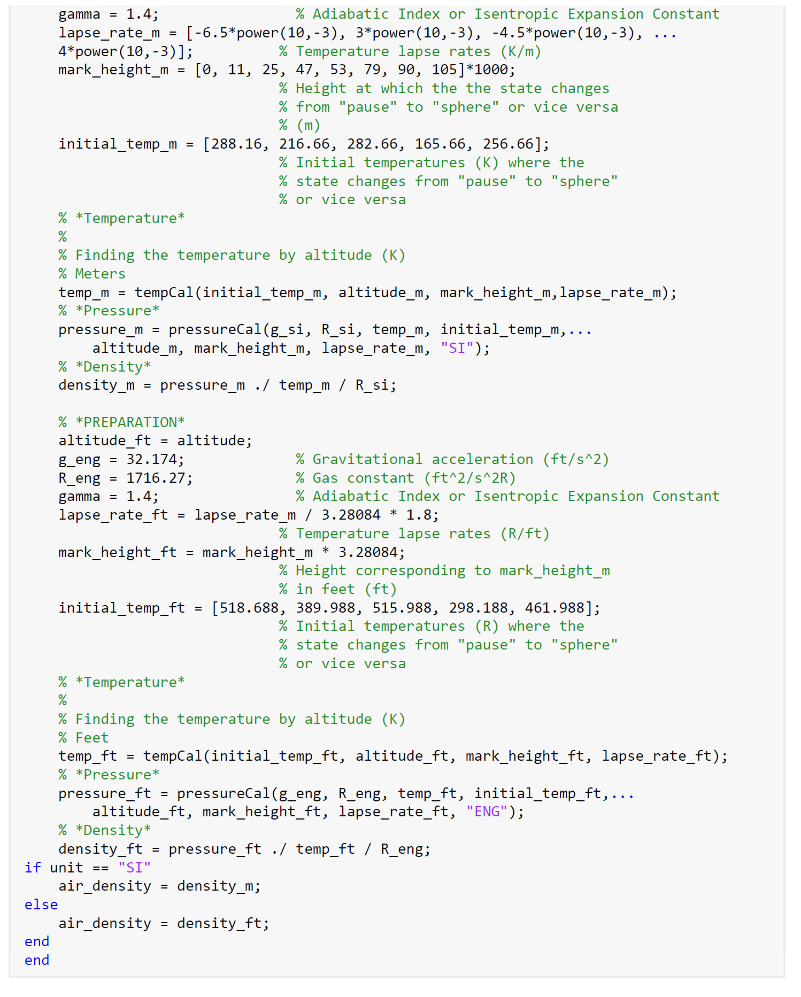

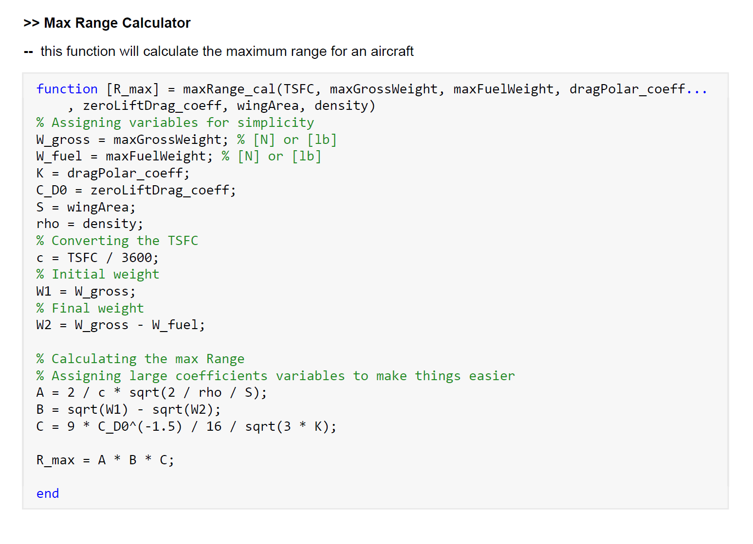

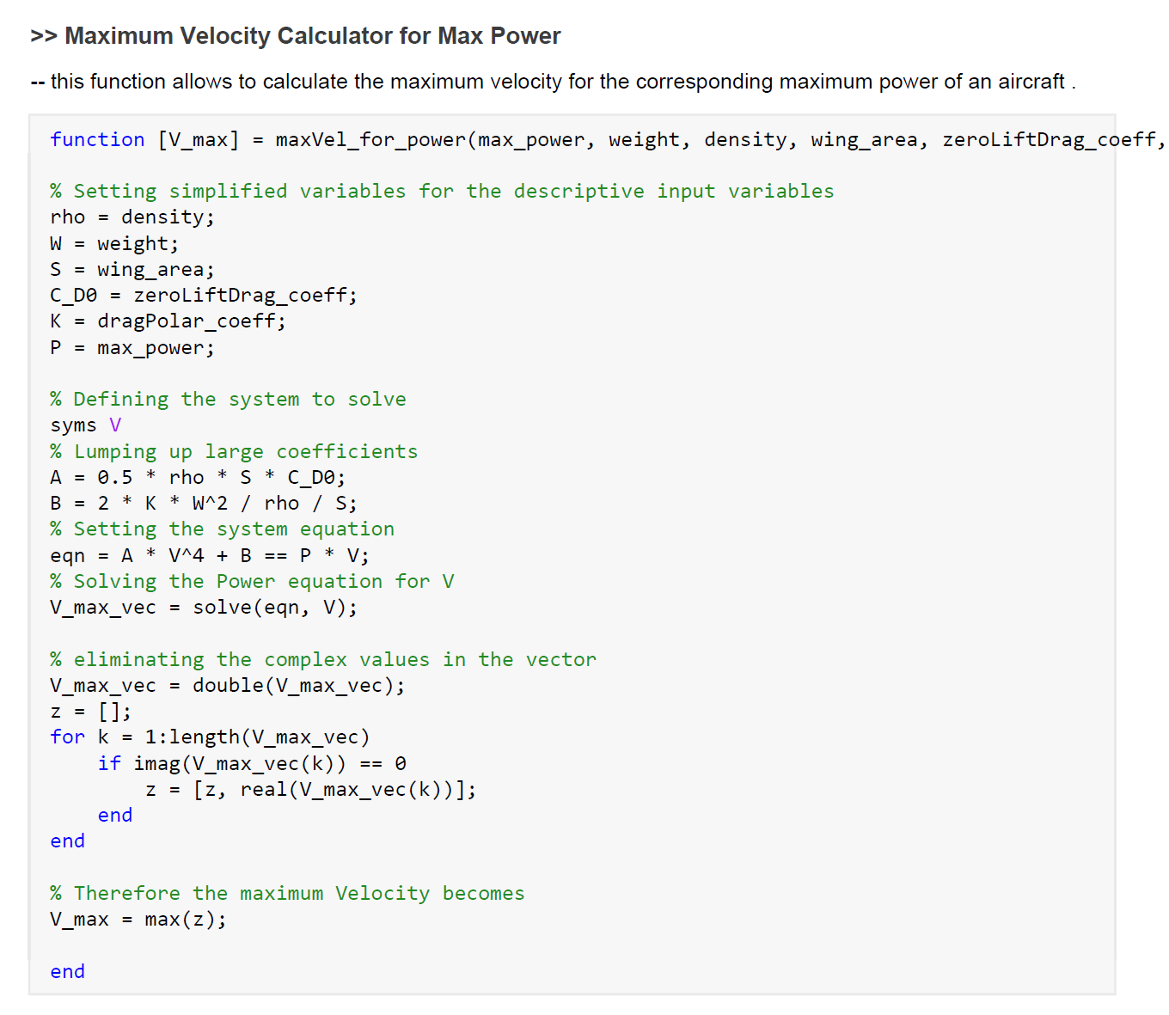

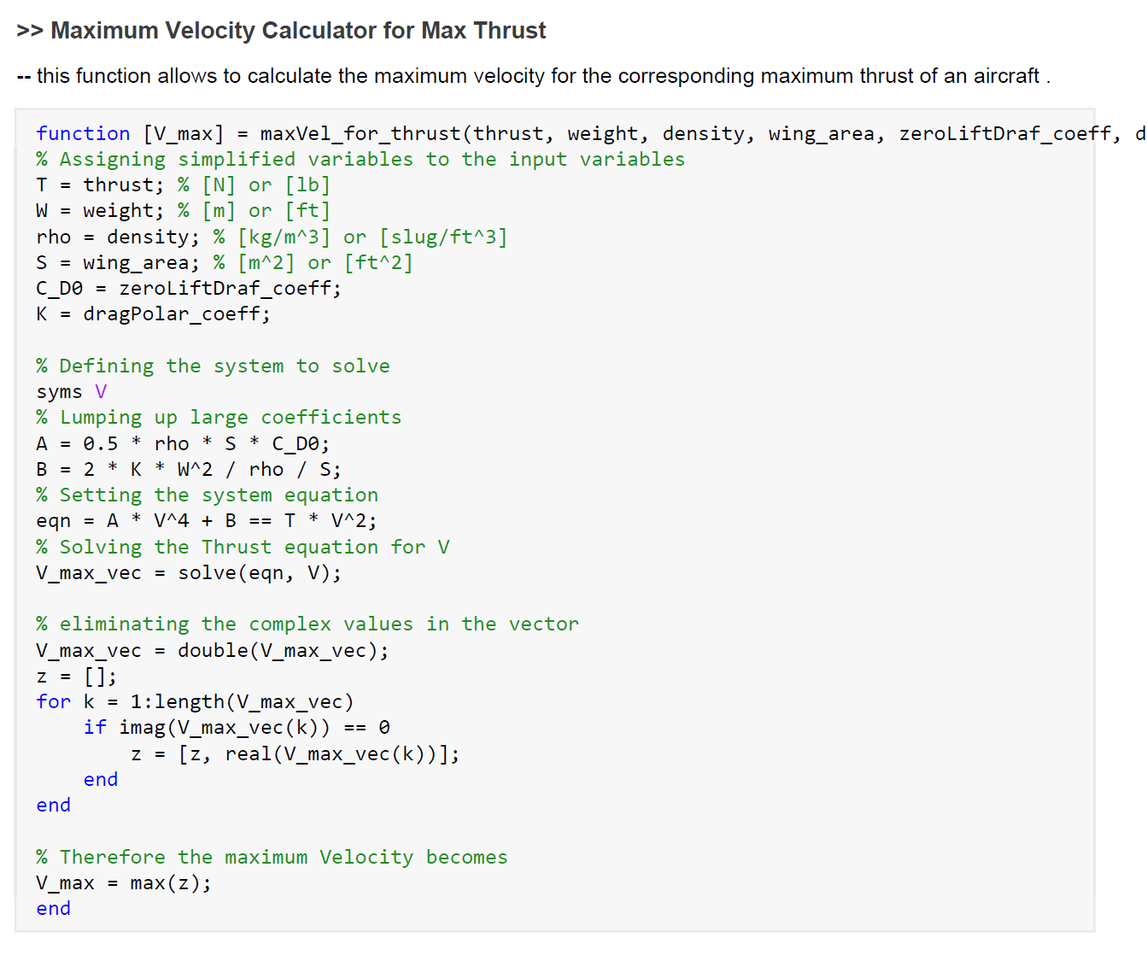

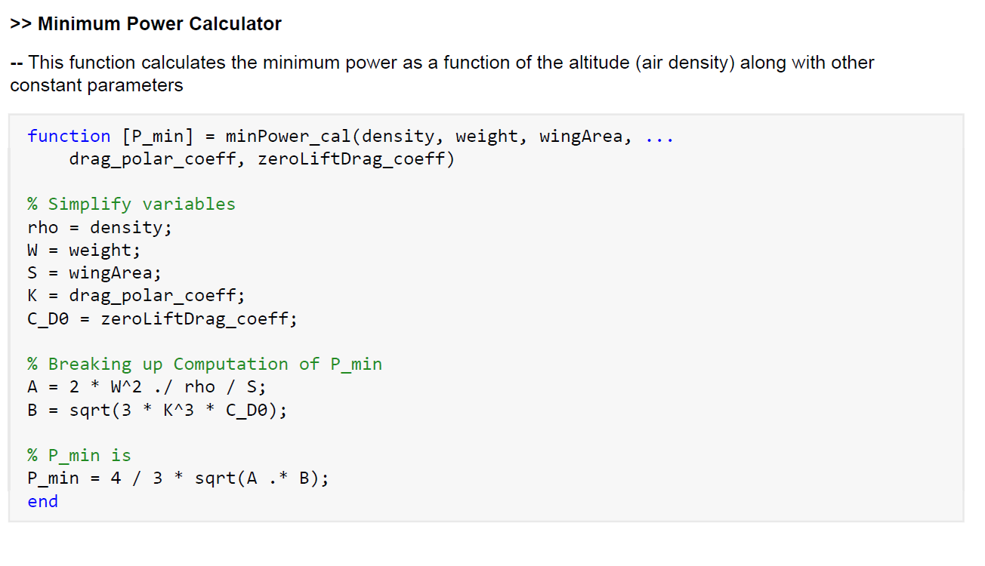

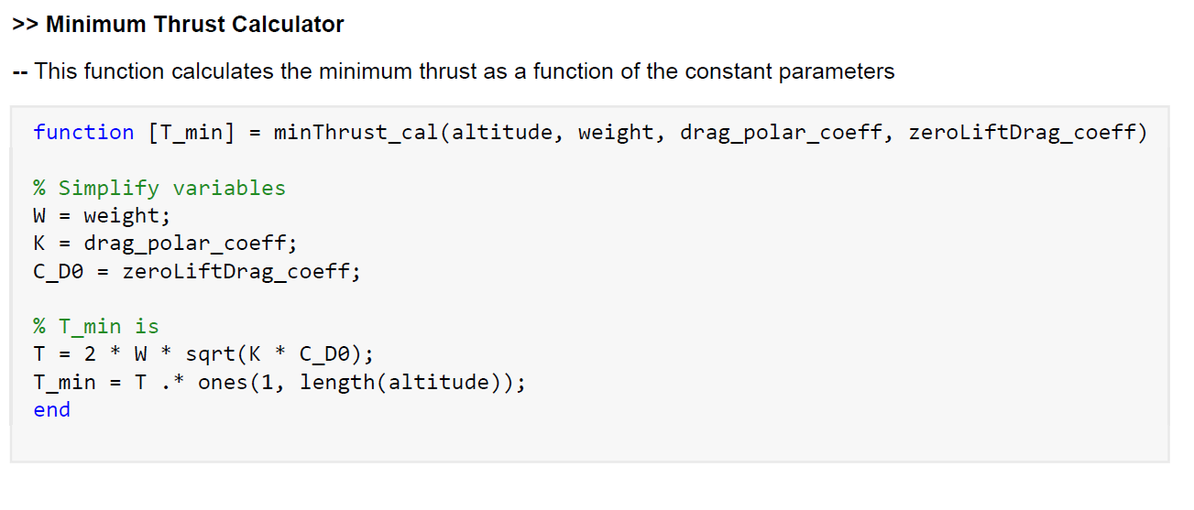

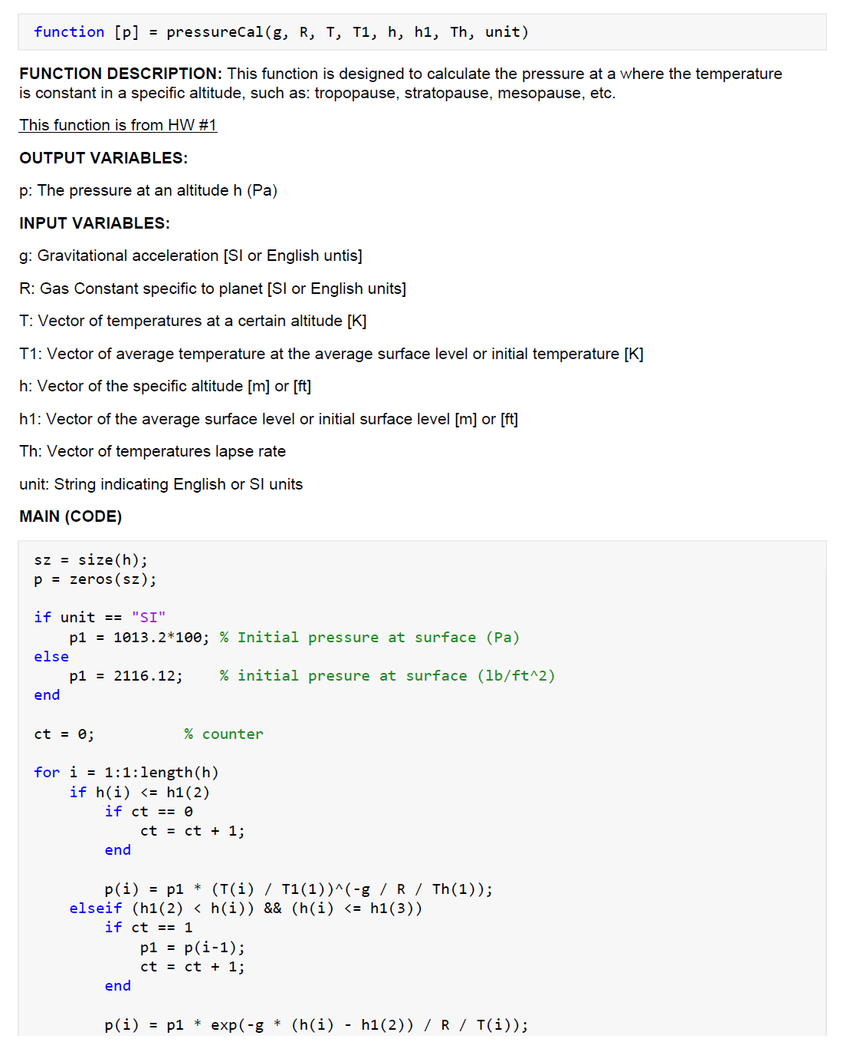

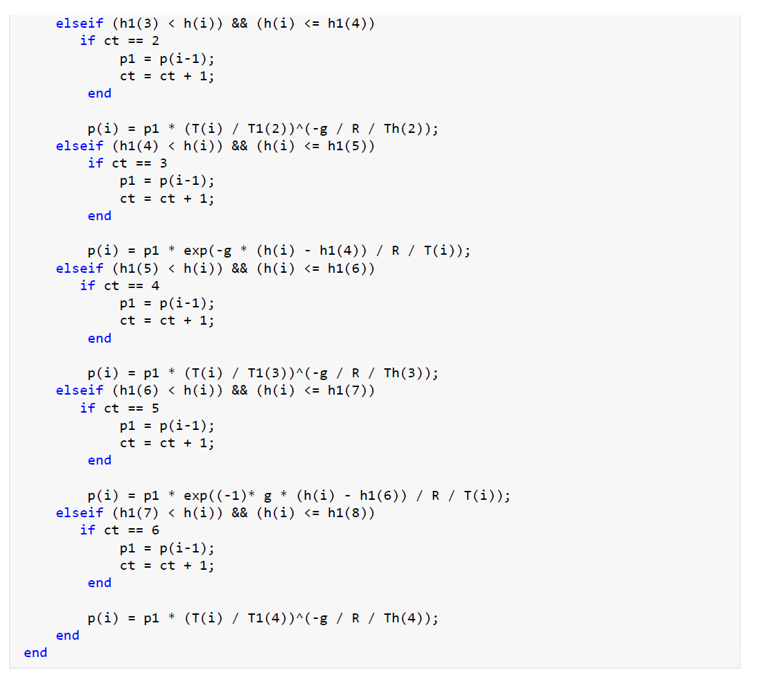

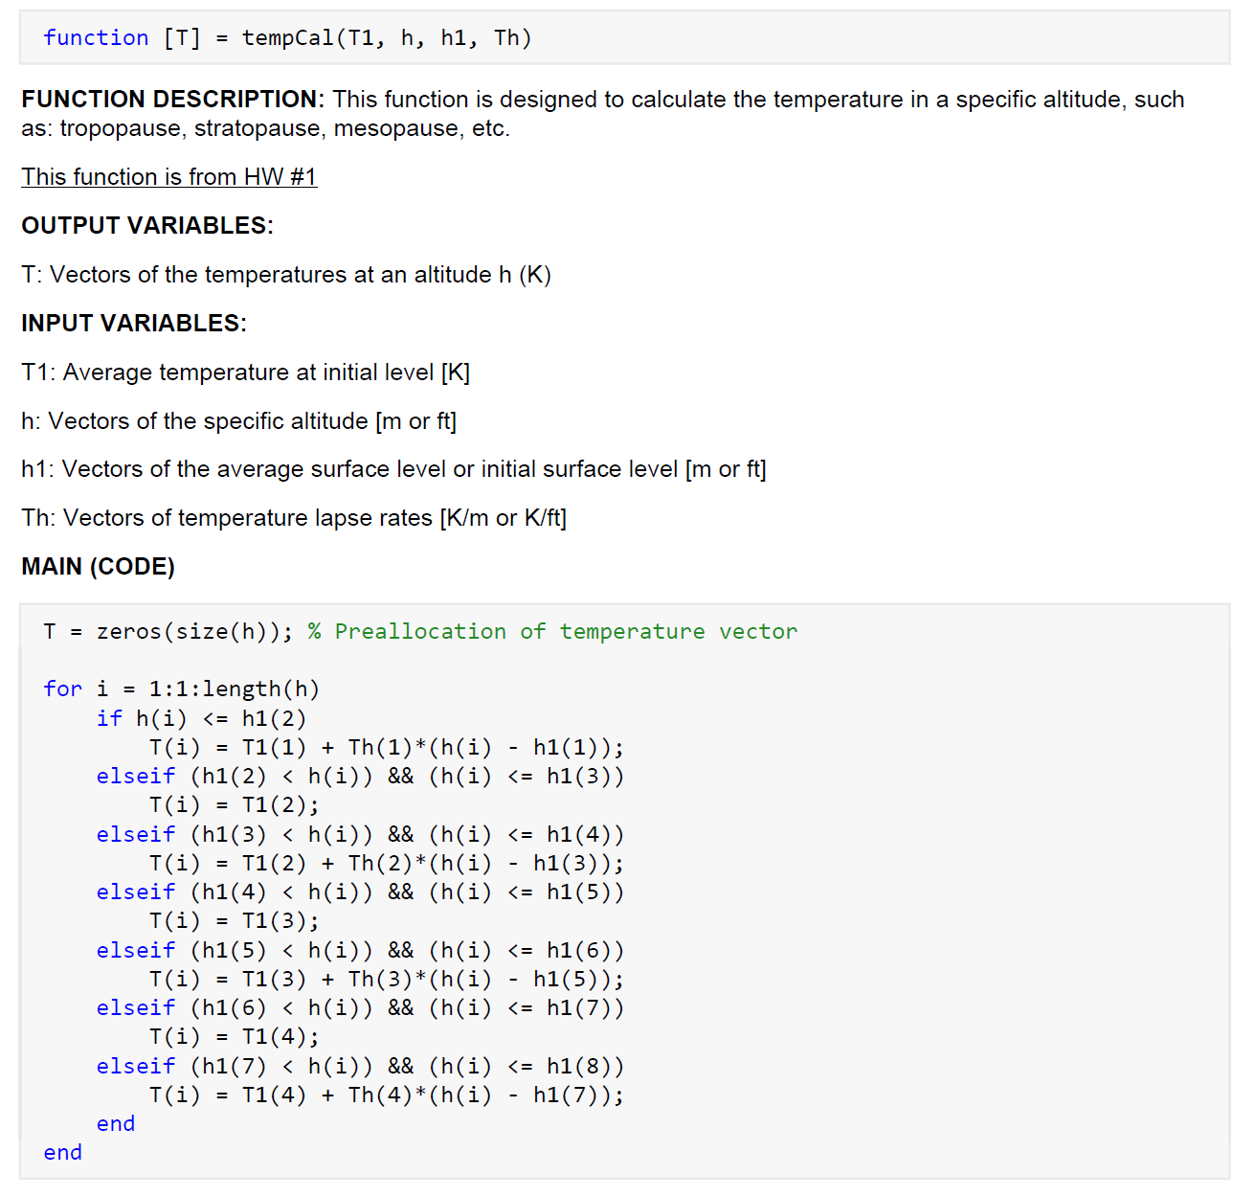

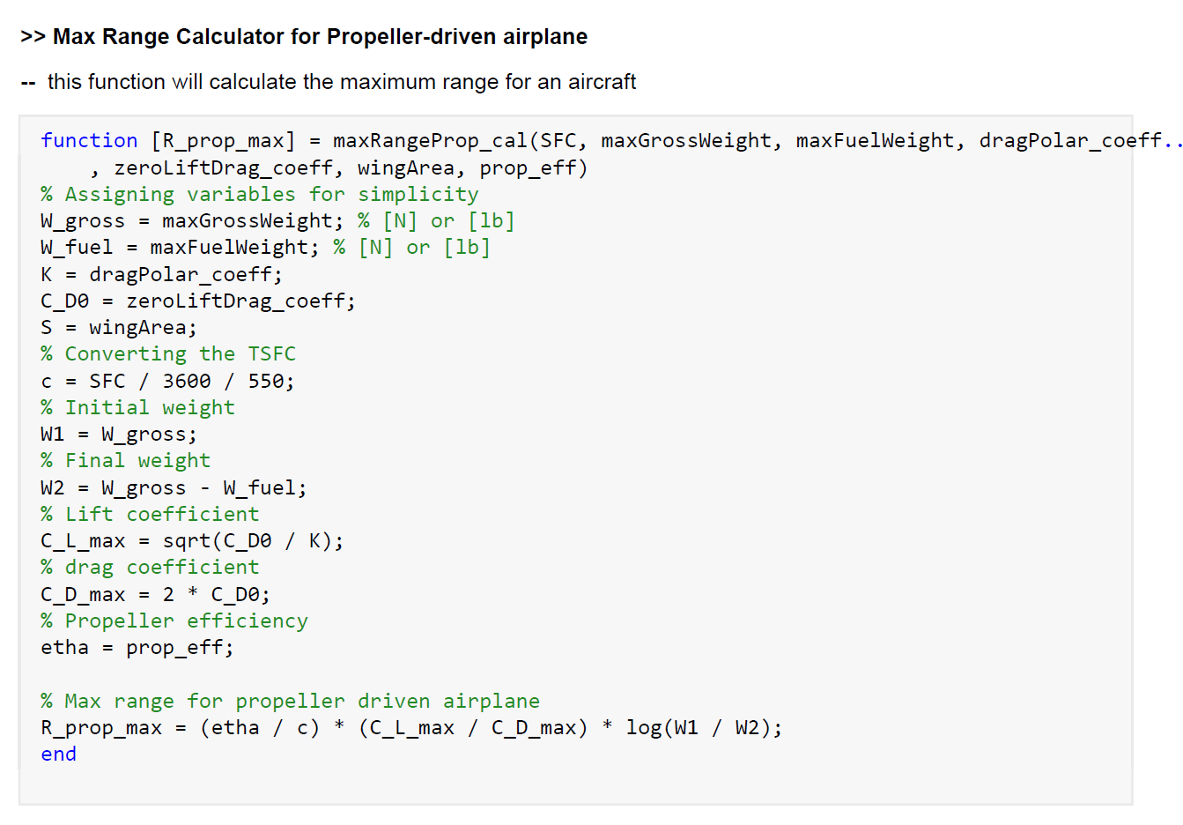

**For this homework you may reuse as many of your Matlab functions from the previous homework as you like, but you must include the code in your response.**

**Question 1**

1. Create a Matlab code to plot the **minimum power** required and power available on the same plot as a function of altitude, given a set of aircraft characteristics.
2. Now use your code on the prop aircraft from your case study notes and paste your plot in your response.
3. Create a Matlab code to plot the **minimum thrust** required and thrust available on the same plot as a function of altitude, given a set of aircraft characteristics.
4. Use your code on the jet aircraft from your case study notes and paste your plot in your response.

NOTE: Once you have written the code for power or thrust, you can easily adapt it for the thrust or power.

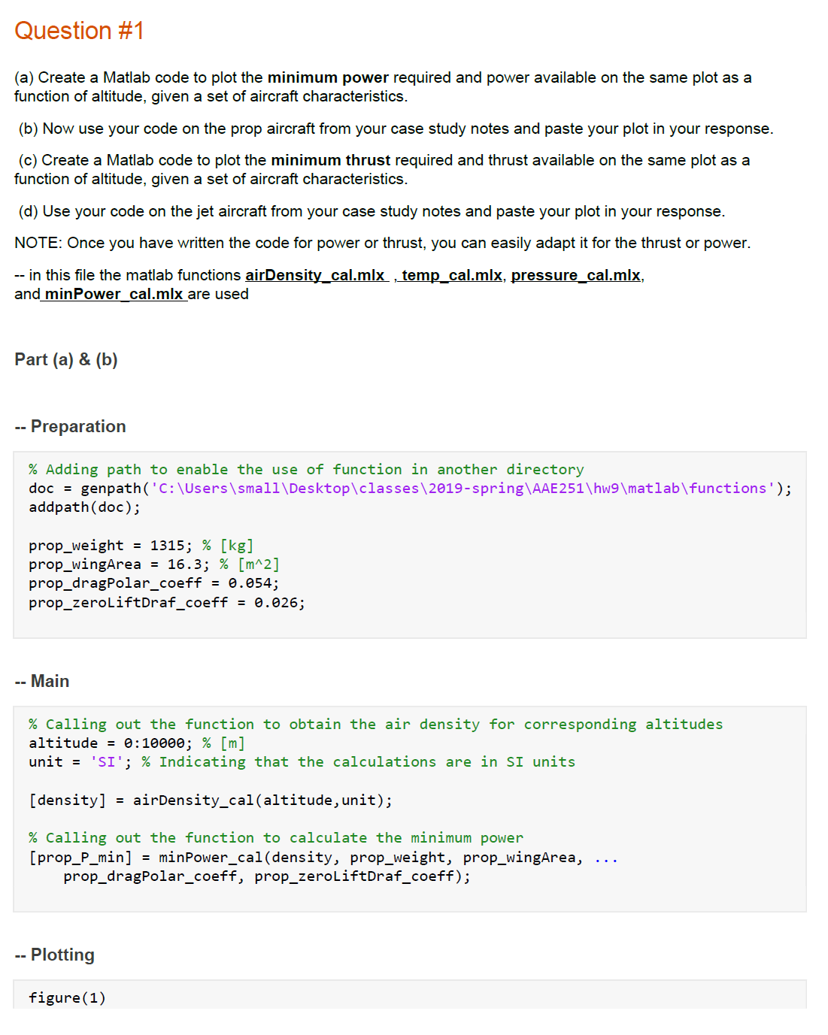

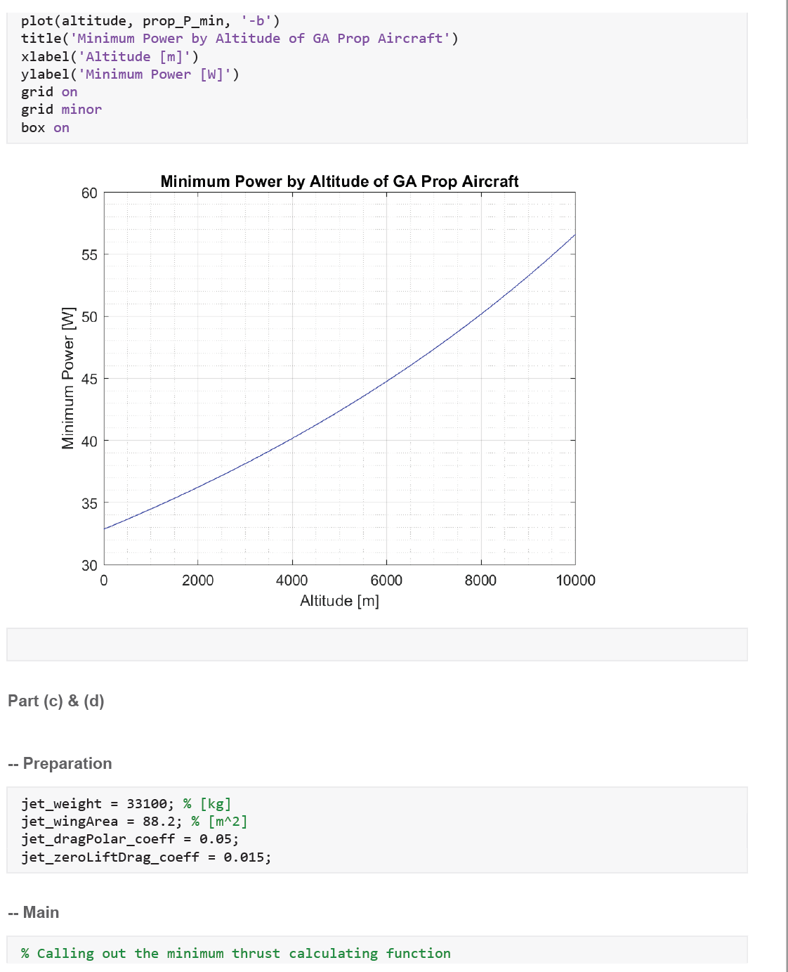

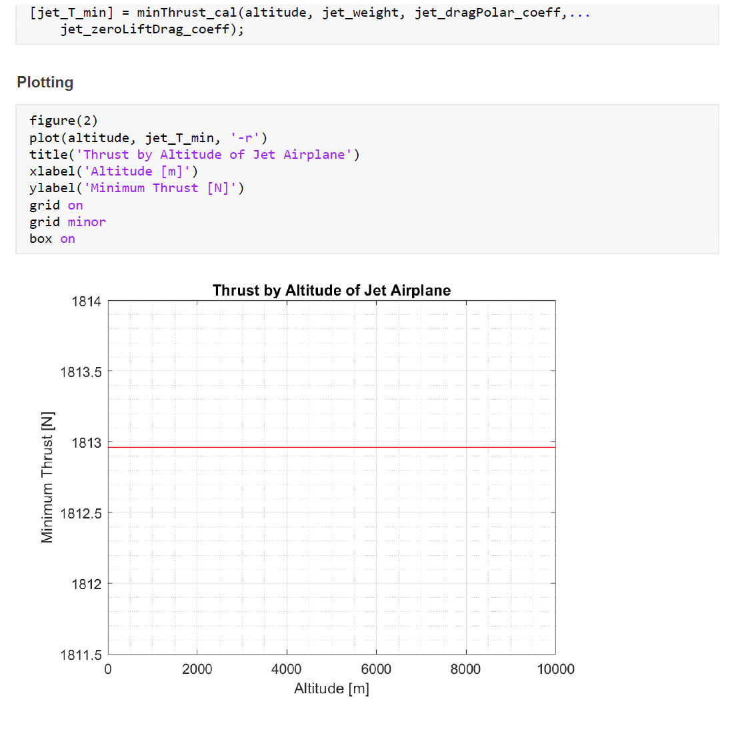

**Question 2**

The Predator UAV has a wing span of and a wing area of Its maximum mass is . The power plant is a Rotax four-cylinder, four-stroke, engine of 85 horsepower, driving a two-blade, variable-pitch pusher propeller. Assume the Oswald efficiency factor is 0.7, the zero-lift drag coefficient is 0.03, and the propeller efficiency is 0.9. Calculate the maximum velocity of the Predator at sea level [You can use MATLAB to solve the polynomial equation].

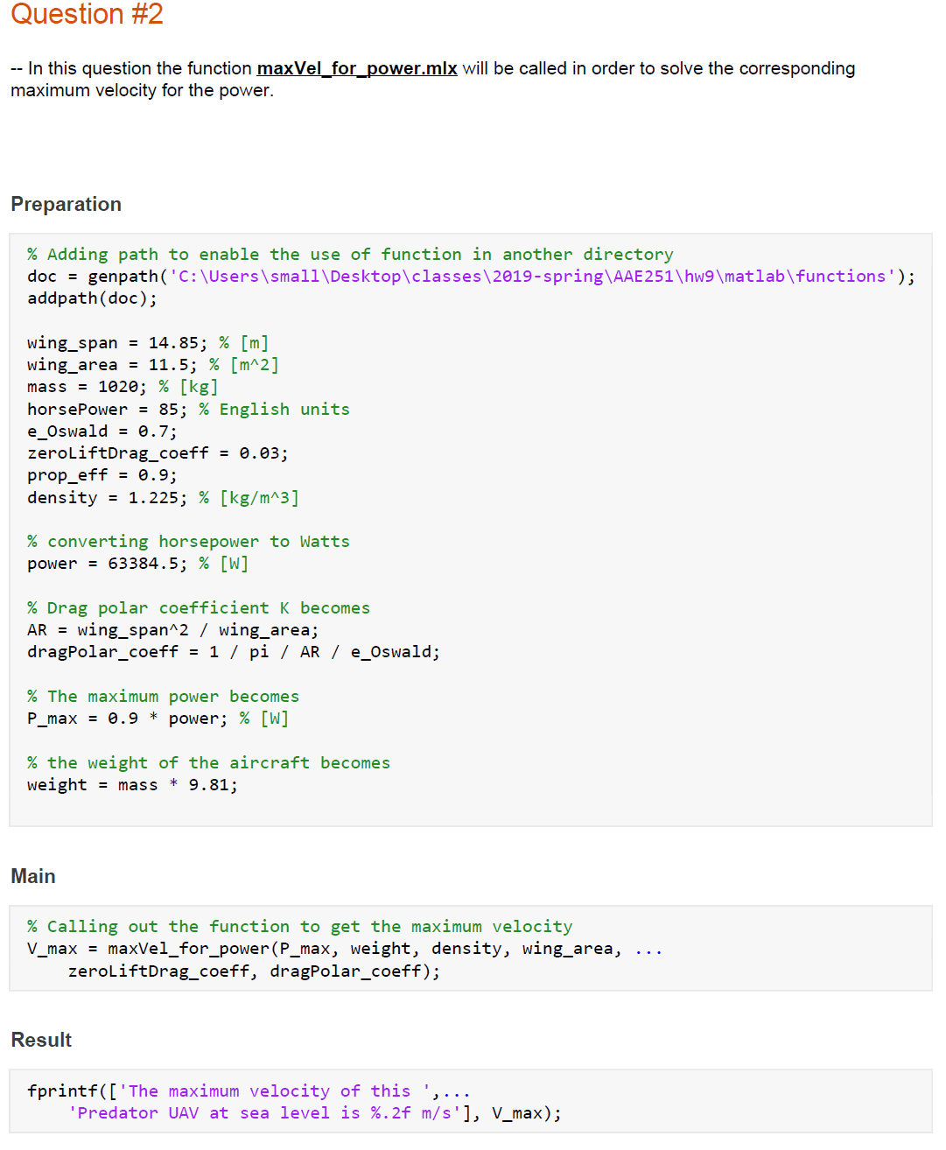

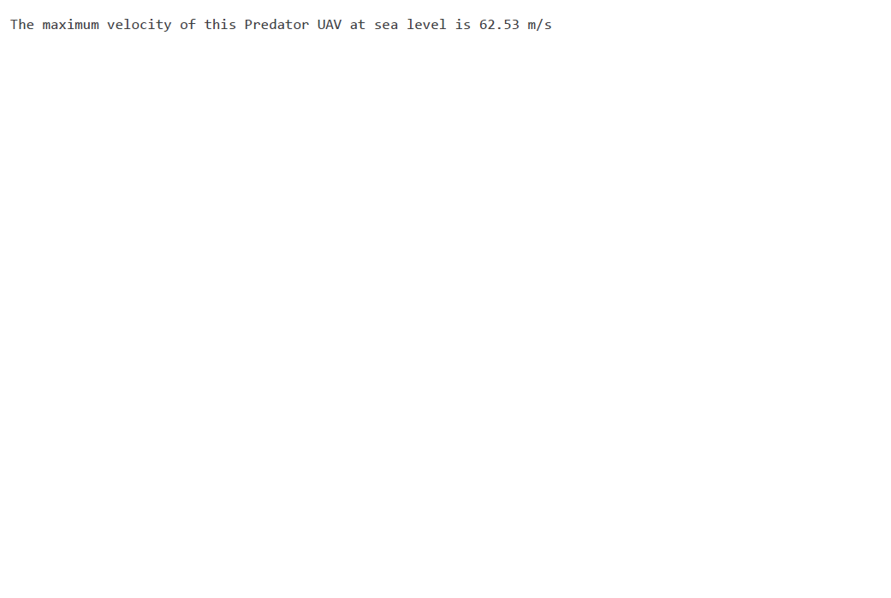

**Question 3**

An aircraft weighs 25,000 kg and has a wing area of 82 m2. Its drag polar is given by

1. Find the minimum thrust required for SLUF and corresponding airspeed at sea level.
2. Find the minimum power required for SLUF and corresponding airspeed at sea level.

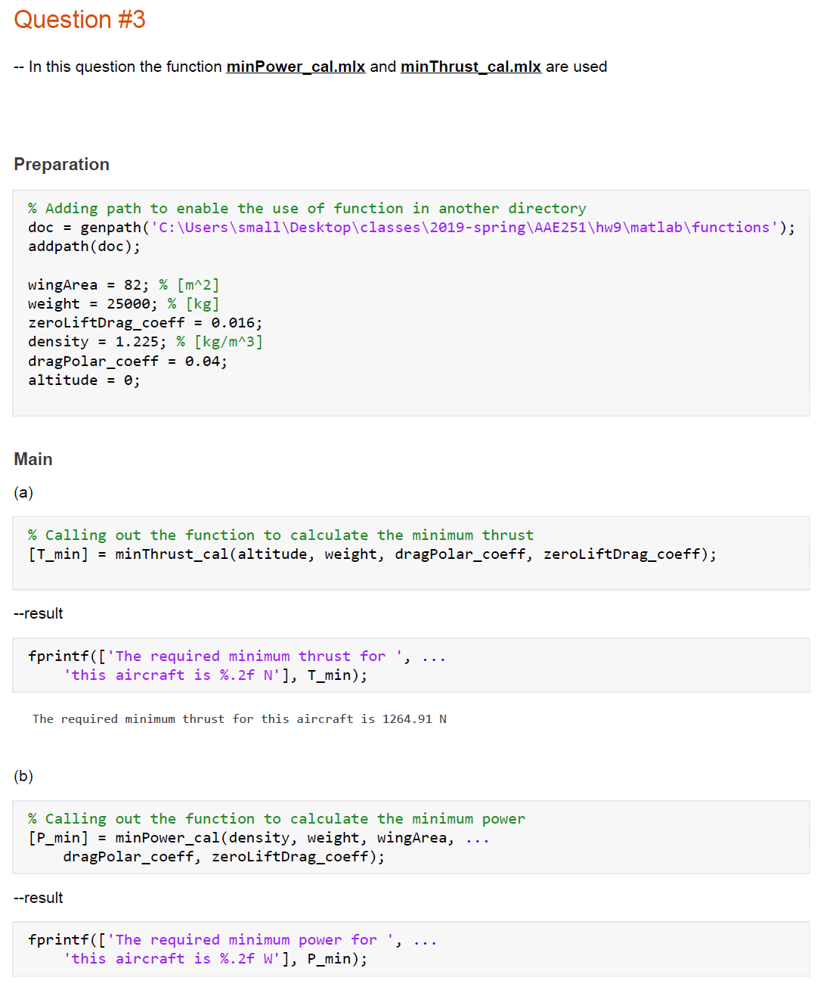

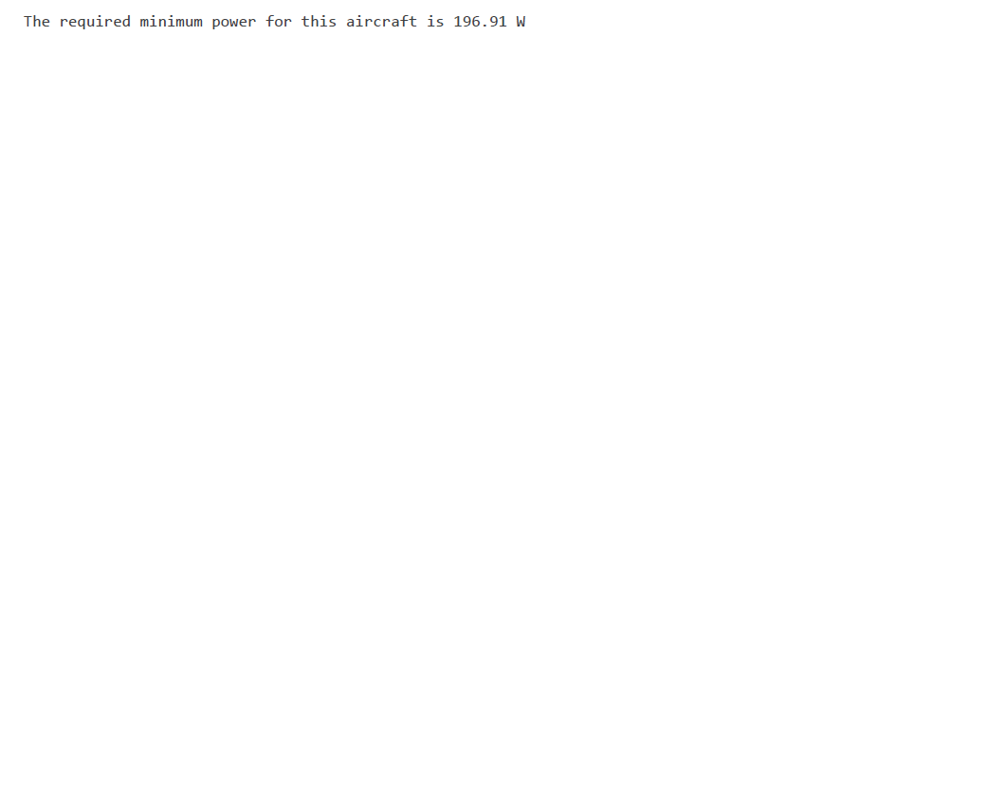

**Question 4**

The Douglas DC-3 has a maximum velocity of at an altitude of 7500 ft. Its engines provide a maximum power of 1200 hp. Its weight is 25,000 lb, aspect ratio is 9.14, and wing area is 987 ft2. Assume that the propeller efficiency is 0.9, equal to 1, and the Oswald efficiency factor is 0.7. Calculate the zero-lift drag coefficient for the DC-3.

Density = 1.8975E-3

|  |
| --- |
|  |

**Question 5**

Consider an airplane patterned after the A-10. The airplane has the following characteristics:- wing area = 47 m2, aspect ratio = 6.5, Oswald efficiency factor = 0.87, and zero lift drag coefficient = 0.032. The TSFC is 1 N of fuel per newton of thrust per hour, the weight of fuel is 56,370 N, and the maximum gross weight is 136,960 N. Calculate the maximum range at a standard altitude of 8 km.

Density = 5.2578E-1

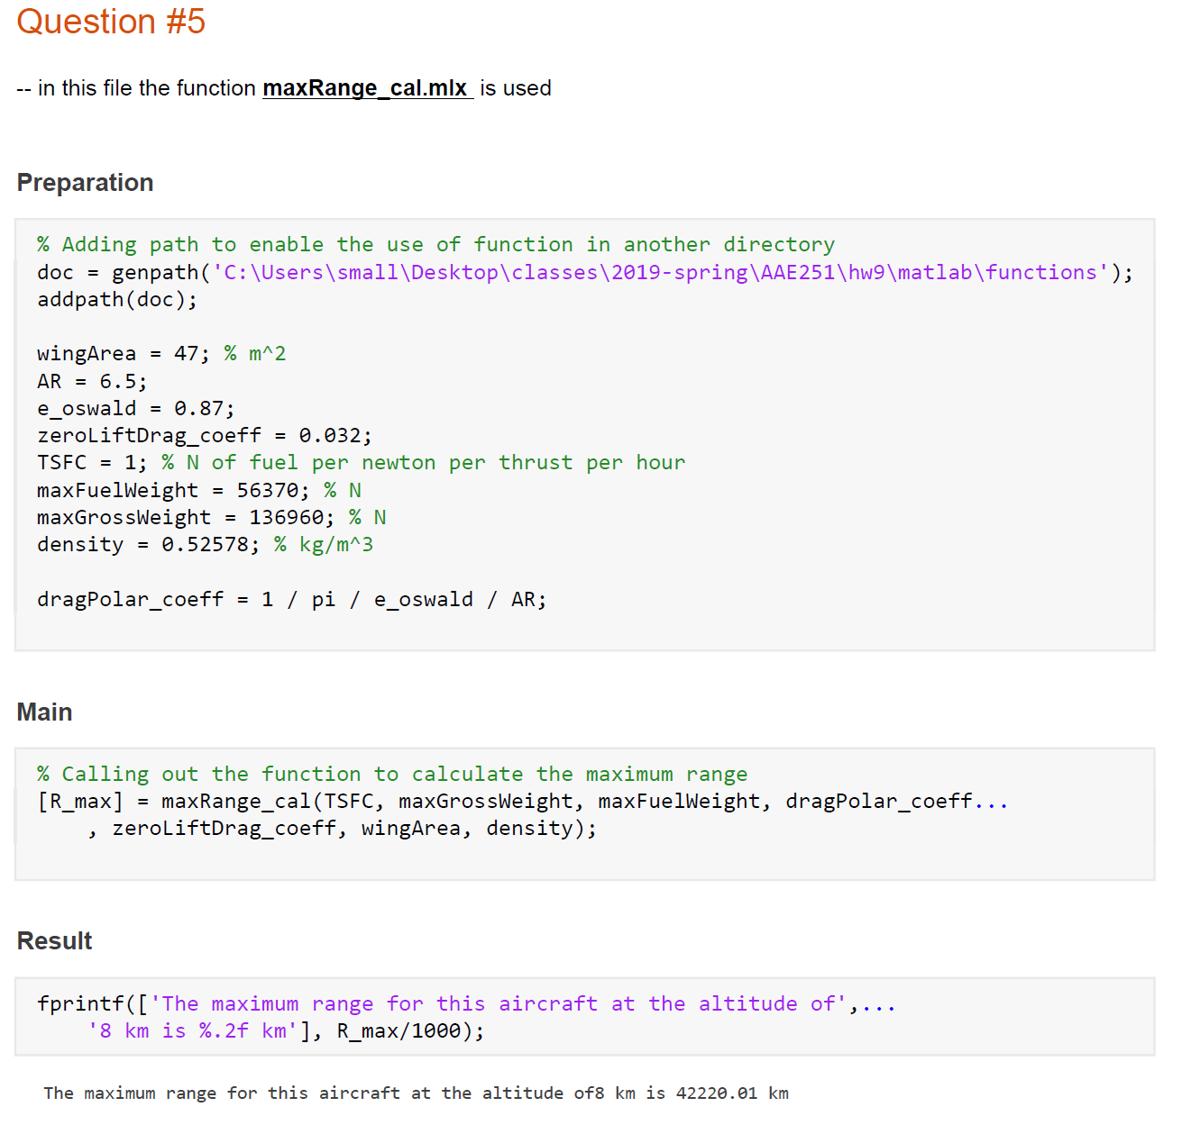

**Question 6**

Consider an airplane patterned after the Beechcraft Bonanza V-tailed single-engine light private airplane. The characteristics of this airplane are as follows: aspect ratio = 6.2, wing area = 181 ft2, Oswald efficiency factor = 0.91, and zero-lift drag coefficient = 0.027. The SFC is 0.42 lb of fuel per horsepower per hour, the weight of the fuel is 248 lb, and the maximum gross weight is 3400 lb. Calculate the maximum range at a standard sea level.

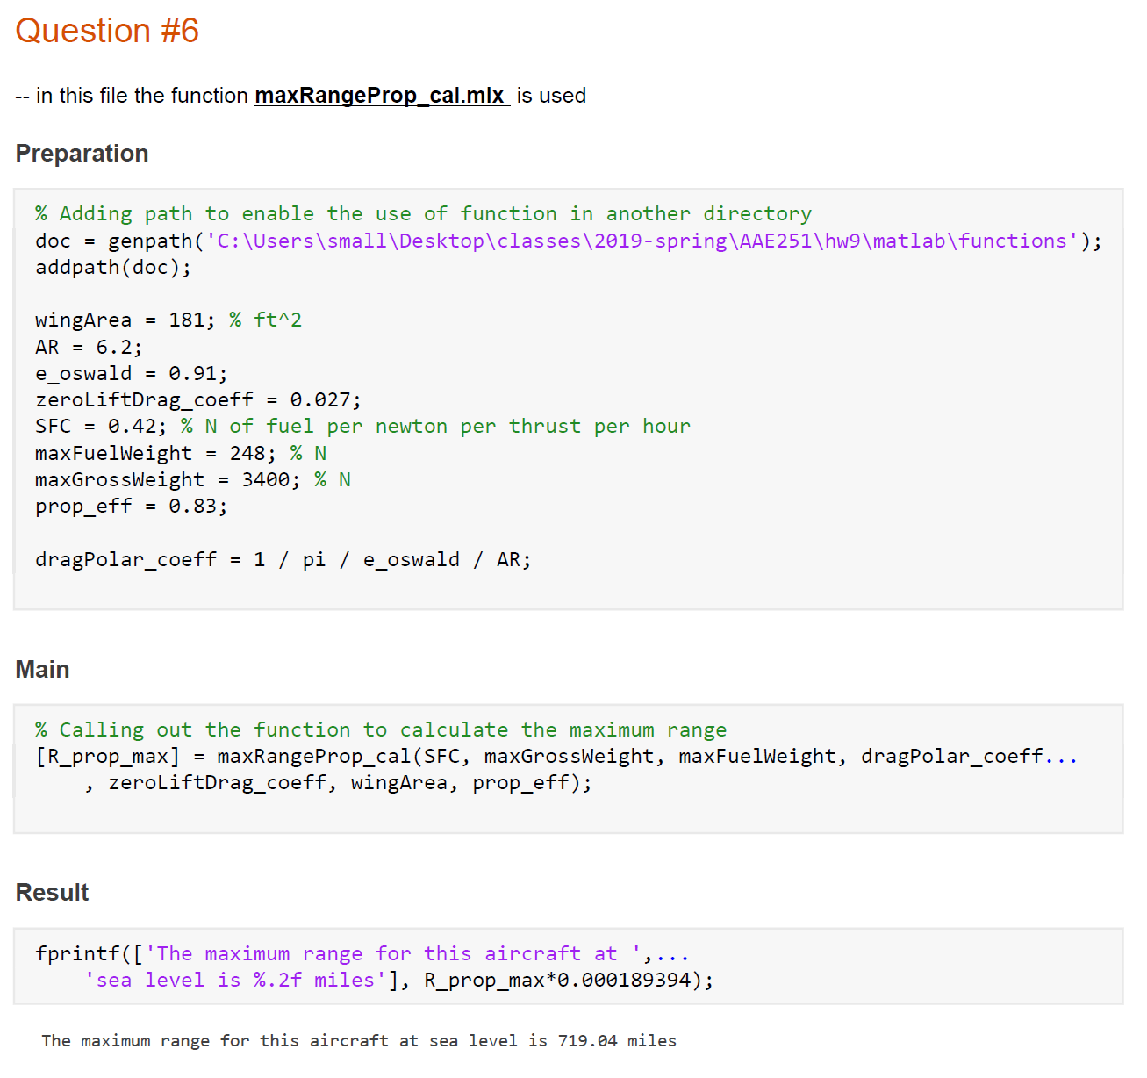

**Question 7**

An aircraft patterned after the Cessna Citation weighs and has a wing area of . Its engines produce a maximum thrust of at sea level where the air density is . The drag polar is given as:

Calculate the maximum airspeed of this aircraft when flying at sea level.

